**AWS Masterclass**

**Part 1 : AWS**

1. **AWS Login Screen with Username**

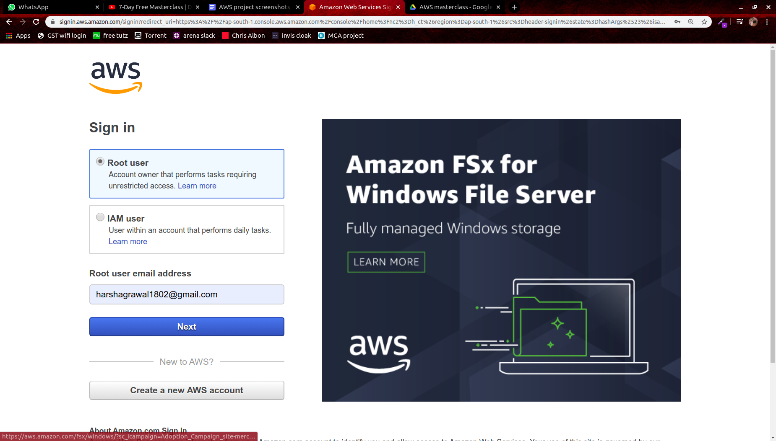

1. **EC2 Dashboard**

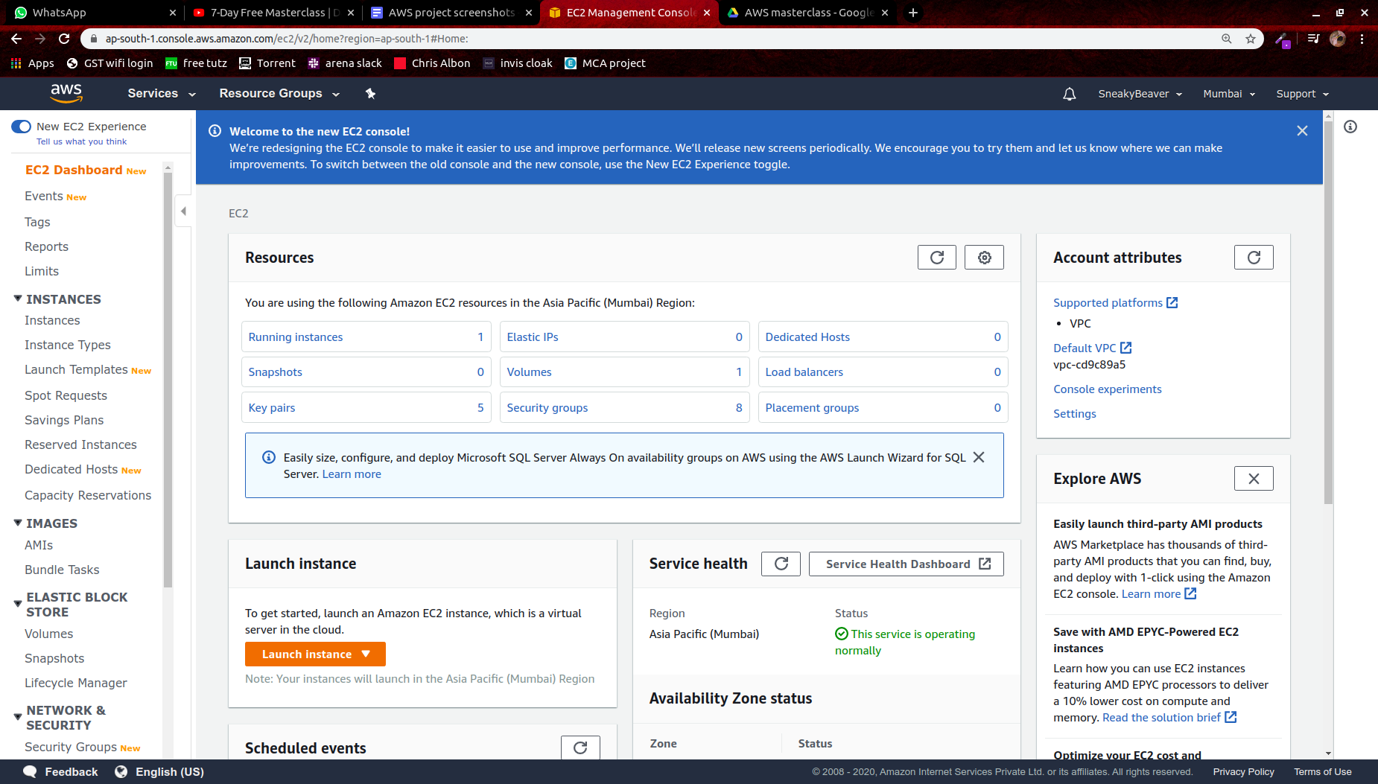

1. **S3 Dashboard**

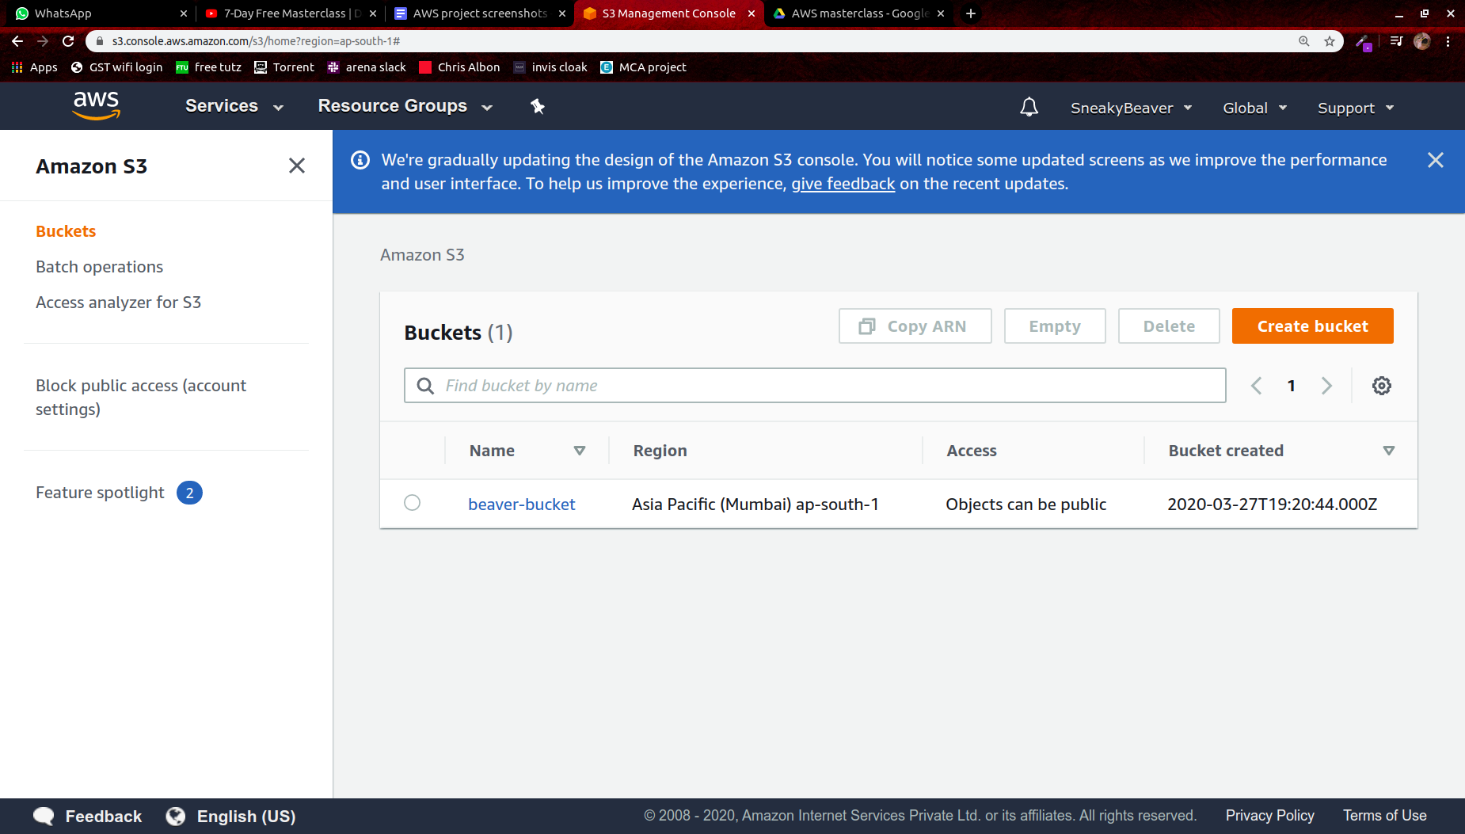

1. **Rekognition Dashboard**

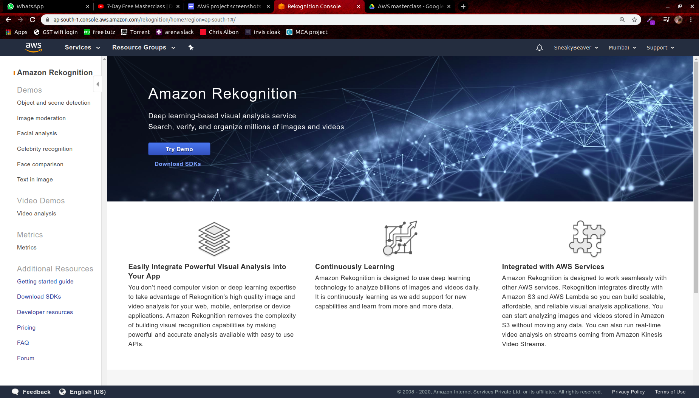

**Part 2 : EC2**

1. **Choosing an AMI**

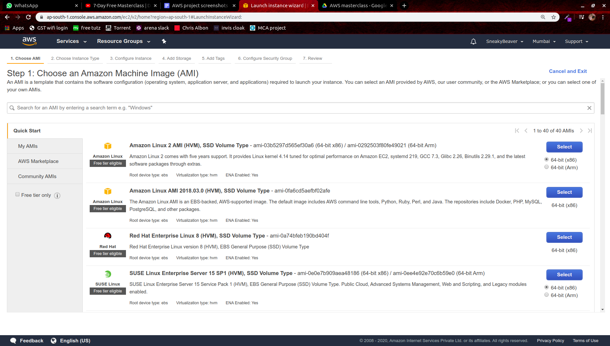

1. **Choosing an instance type**

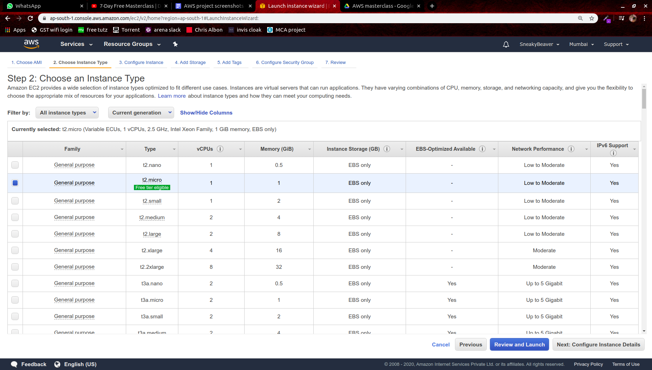

1. **Adding Storage**

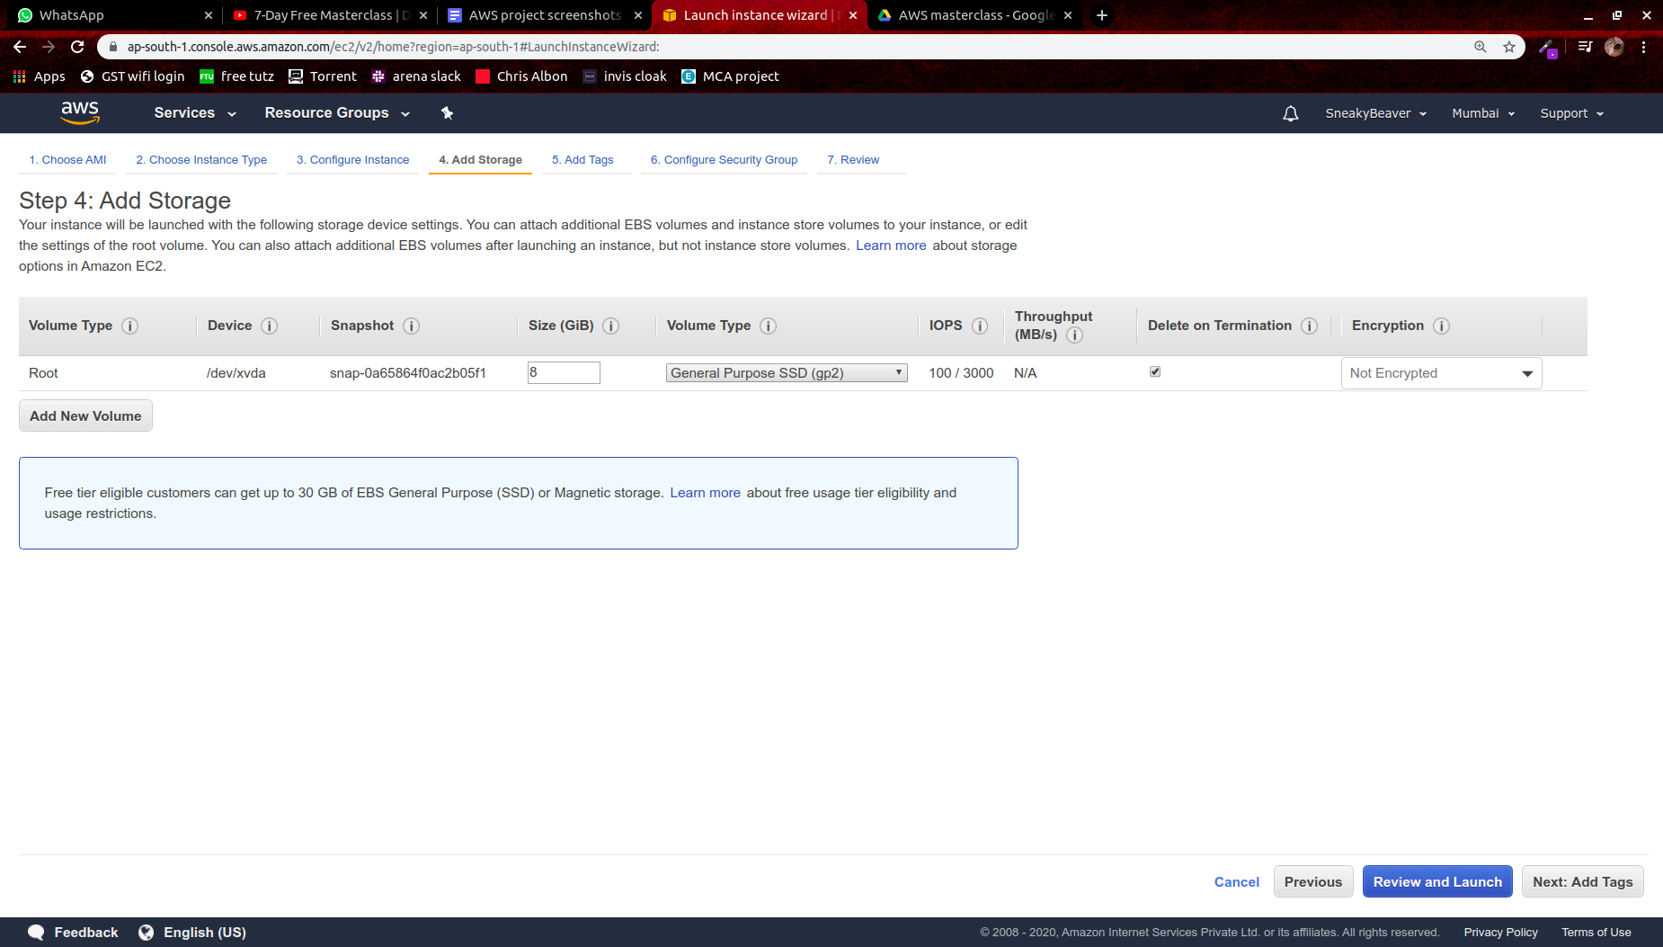

1. **Configuring Security Group**

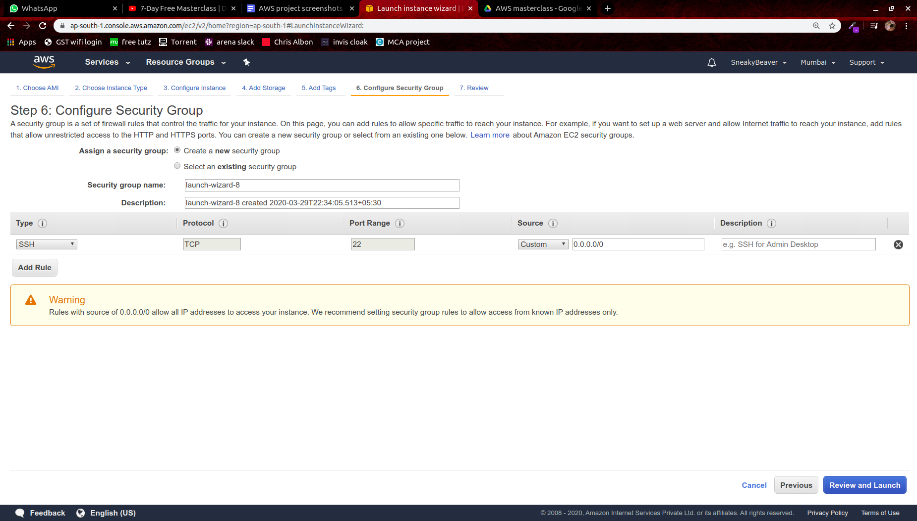

1. **Key Pair Download**

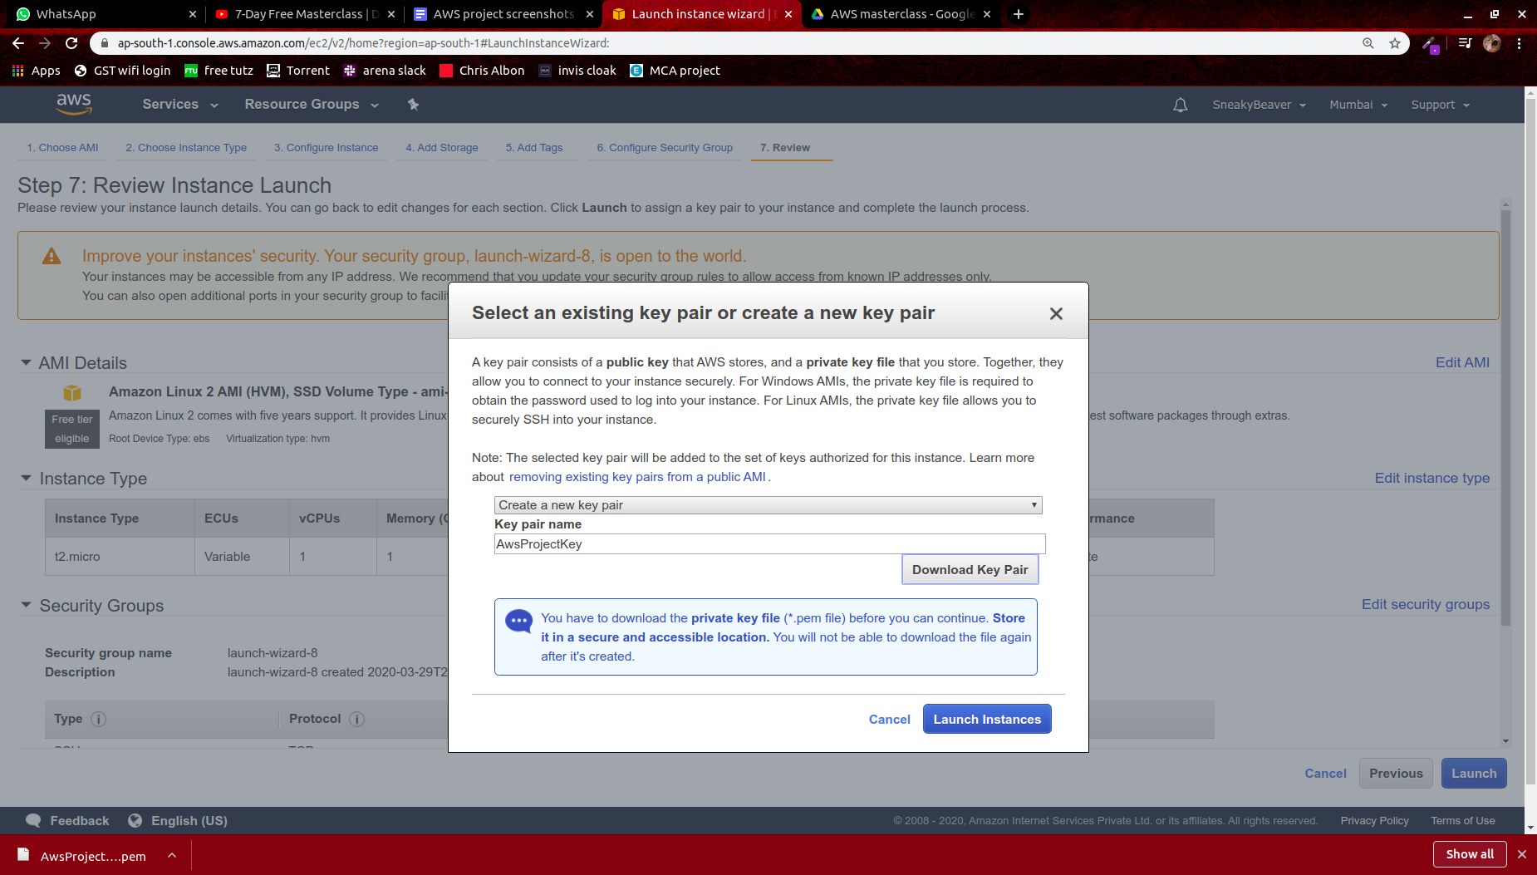

1. **Puttygen Conversion from pem to ppk**

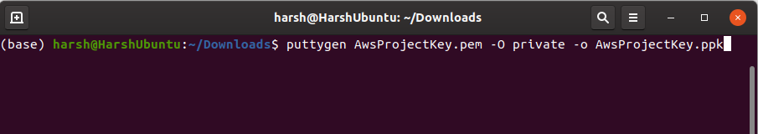

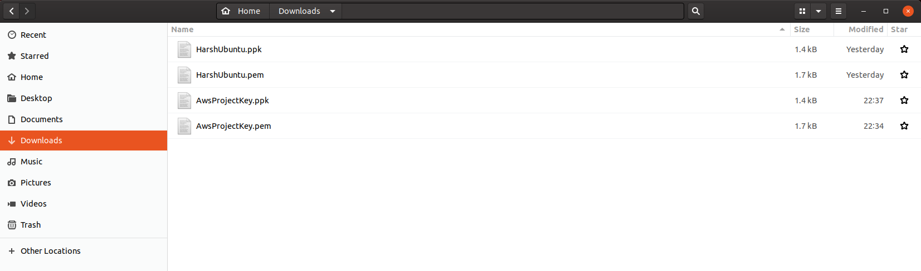

1. **Logged in EC2 Black Screen**

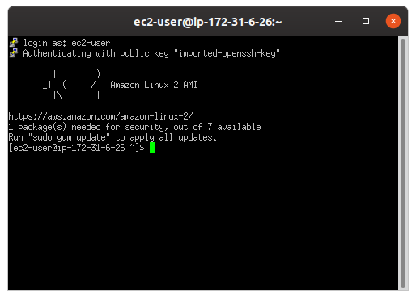

**Part 3 : S3**

1. **Creating a bucket**

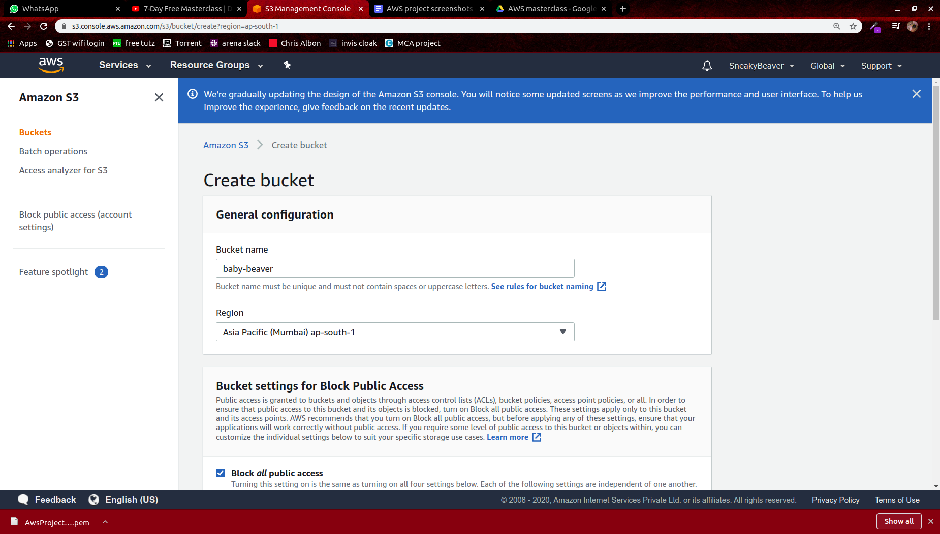

1. **Uploading an Object**

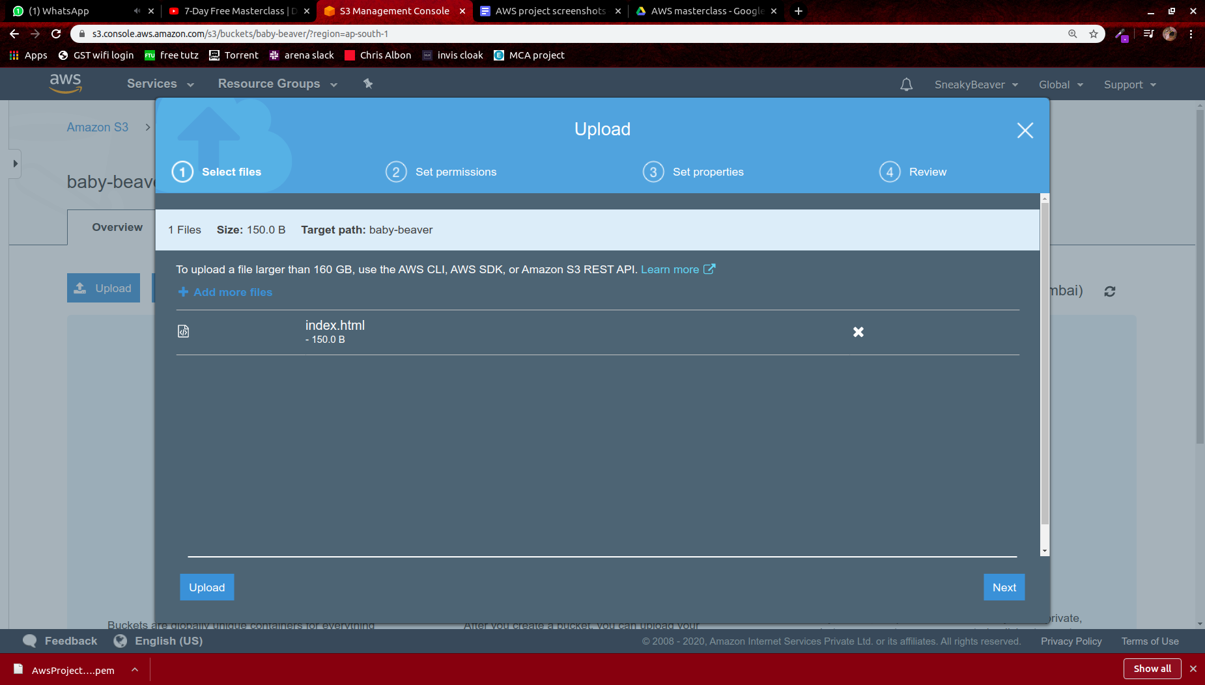

1. **Enabling the static website**

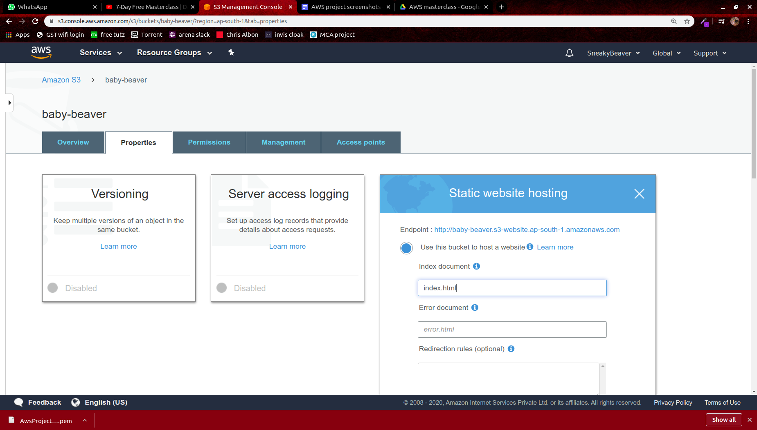

1. **Making the Object Public**

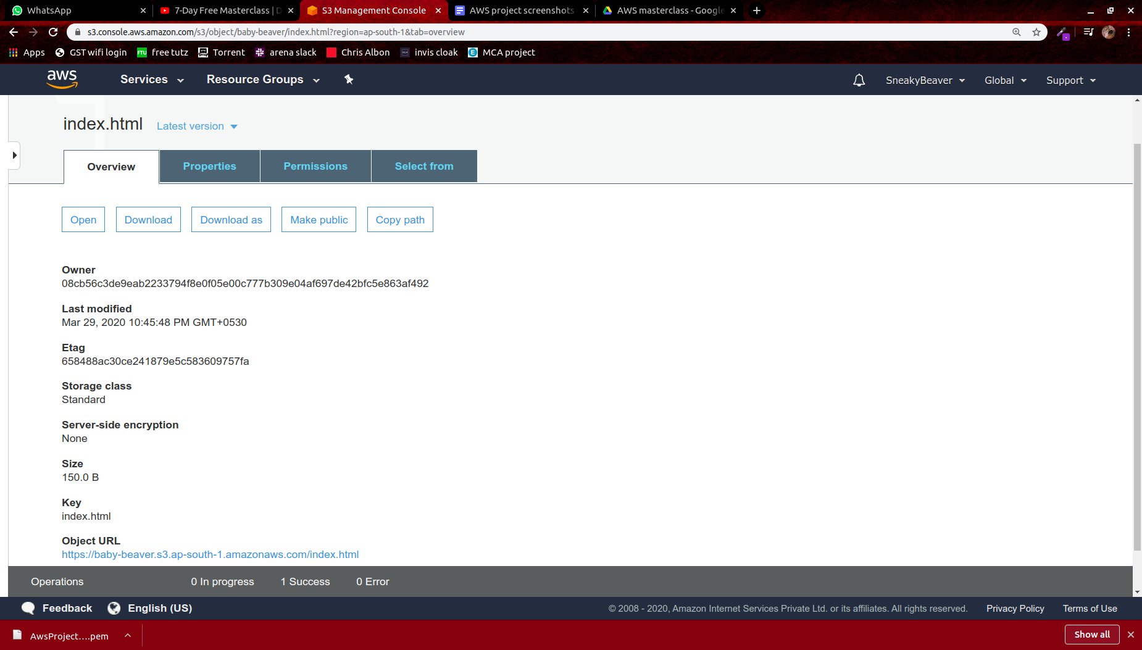

1. **Checking the S3 link on browser**

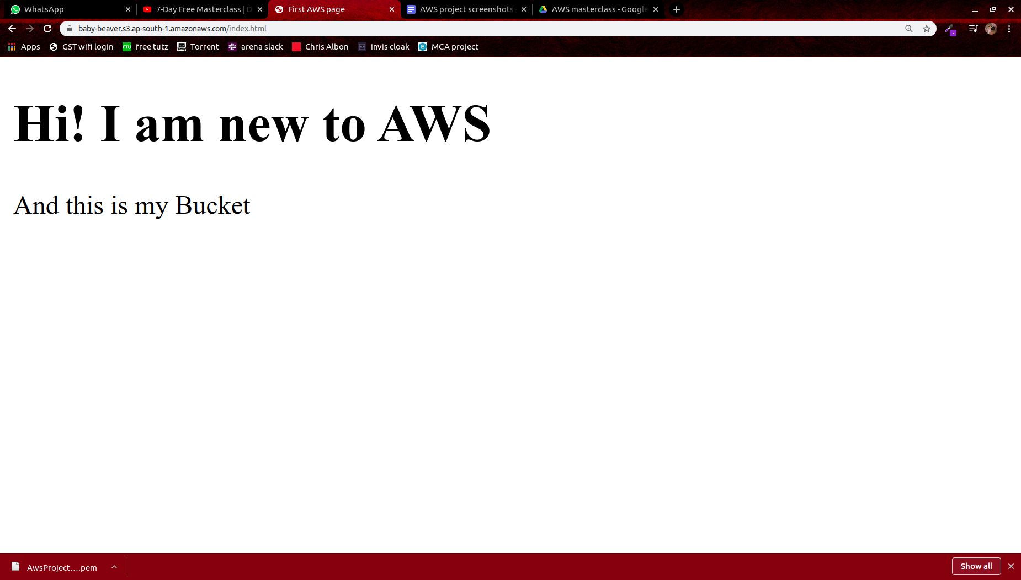

**Part 4 : Rekognition**

1. **Face Detect**

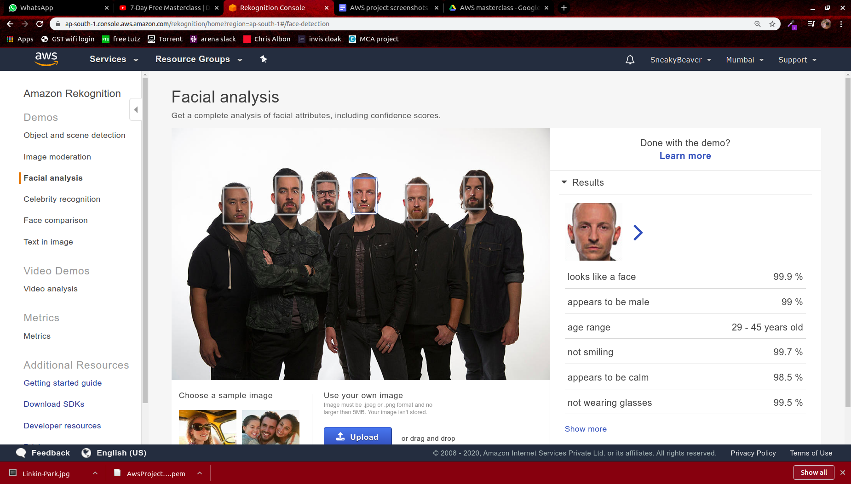

1. **Face Compare**

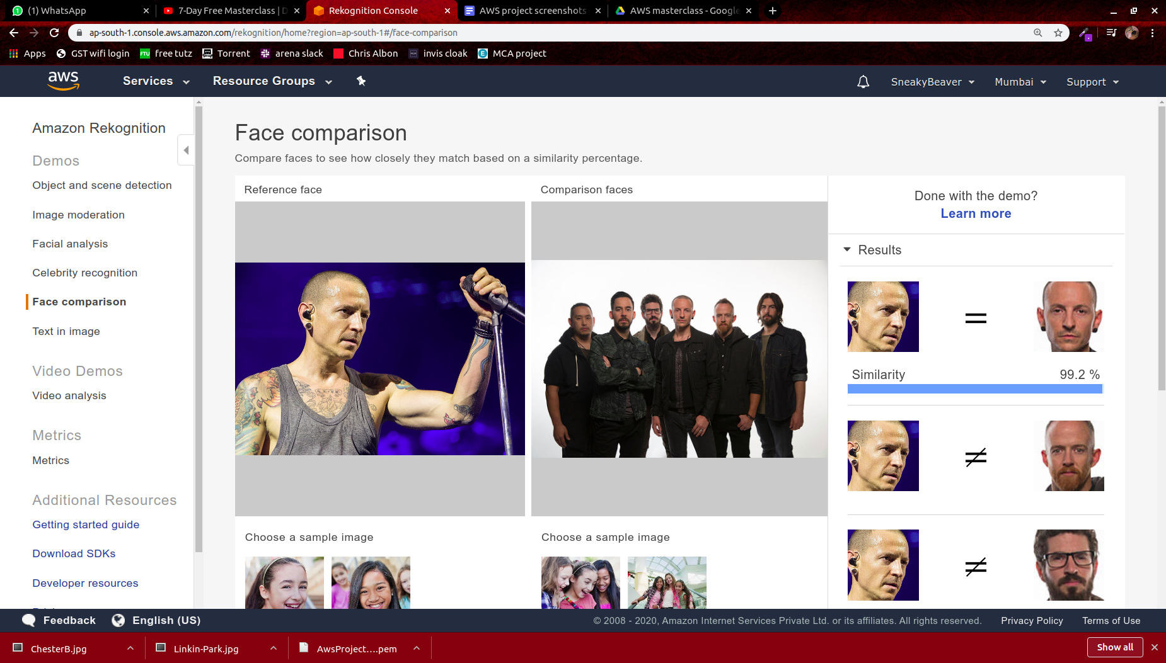

1. **Celebrity Recognition**

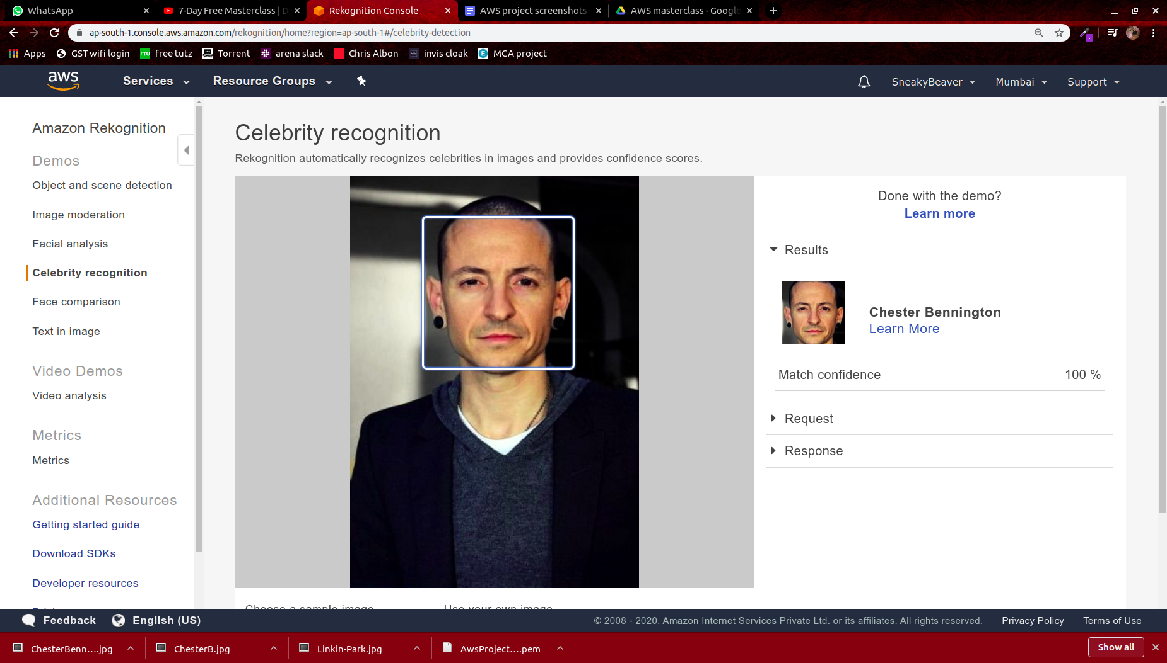

1. **Text in image**

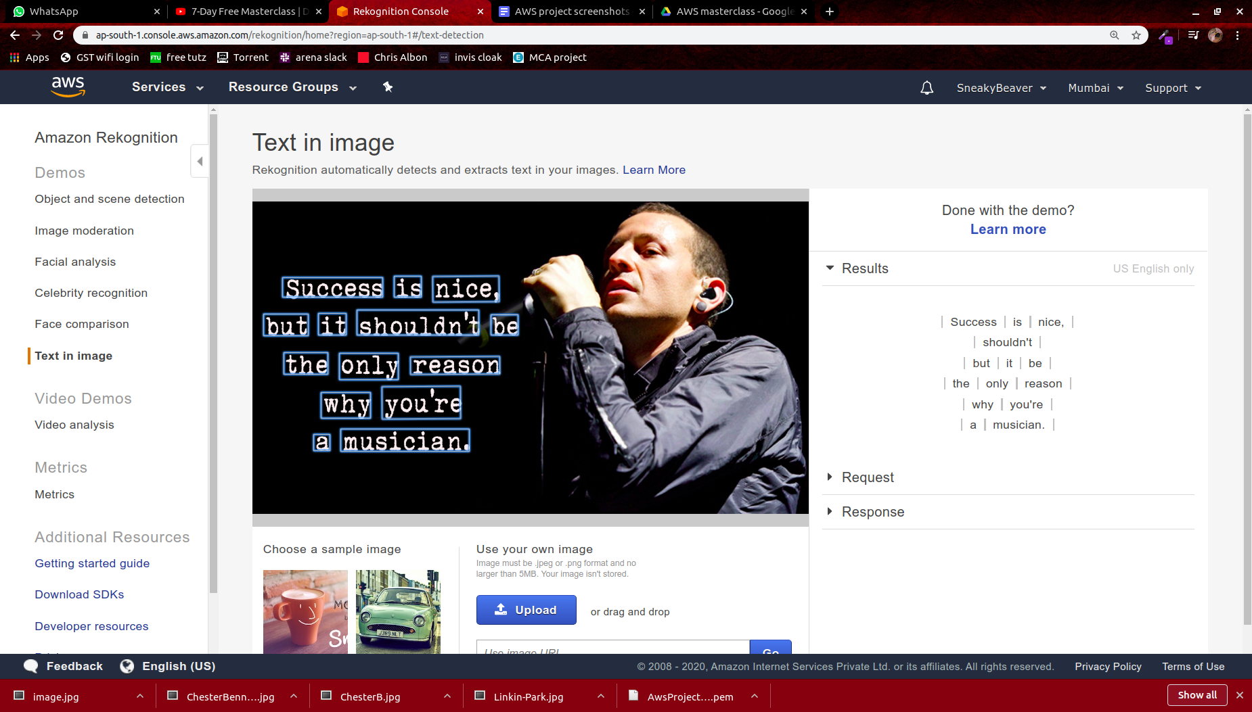

**Part 5 : EC2 and S3**

1. **Installing aws-sdk**

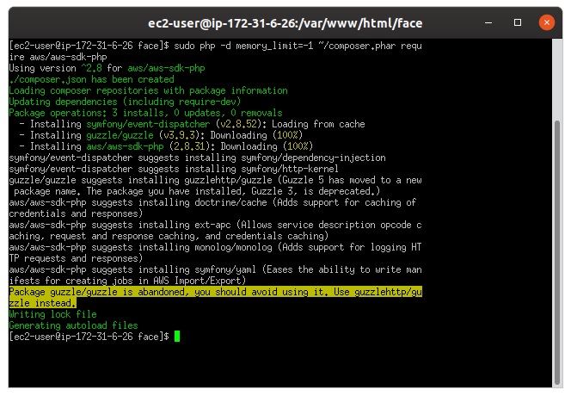

1. **Install php**

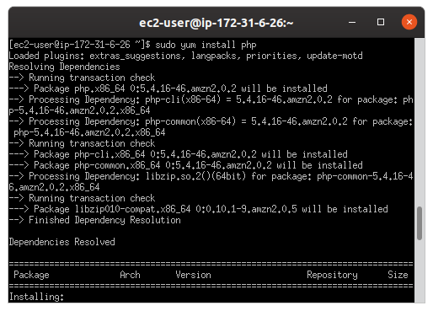

1. **Index.php file Code**

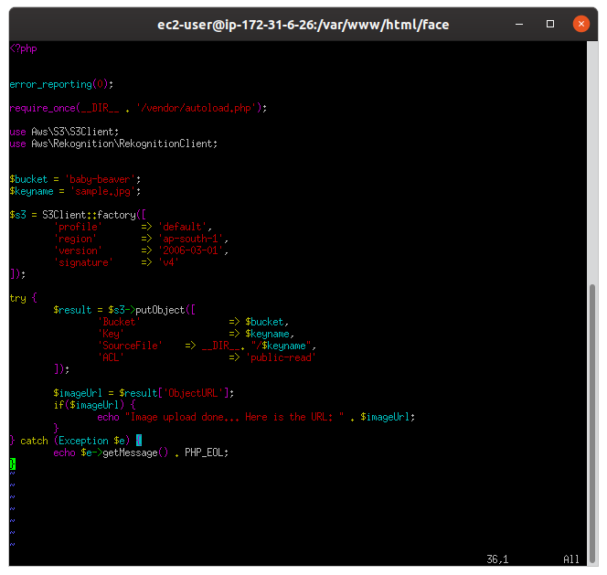

1. **Upload Success screenshot**

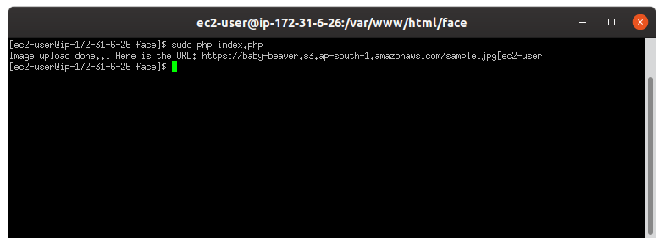

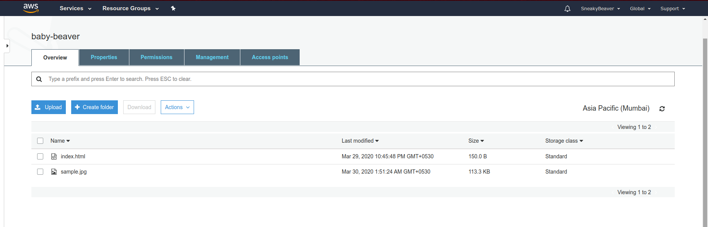

**Part 5 : EC2 and Rekognition**

1. **Face Detect success screenshot**

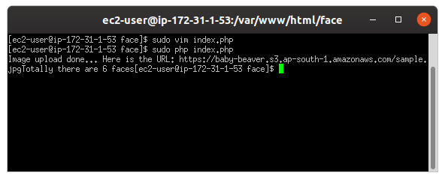

**Input image for this case was:**

